Jenkins Kubernetes Integration
This POC covers the below setup:
1. Installation of jenkins,Docker,Maven on jenkins server
2. Installation of kubernetes cluster (As part of this poc 1 master and 1 worker node)
3. Setup jenkins server to deploy application into kubernetes cluster
4. Build and deploy docker Application from jenkins in kubernetes cluster using pipeline script

Purpose: To deploy application into kubernetes cluster integrating with jenkins automation

Technologies used: EC2 inatances,Git,jenkins,Maven,Docker,Dockerhub,Kubernetes cluster

Workflow Diagram:

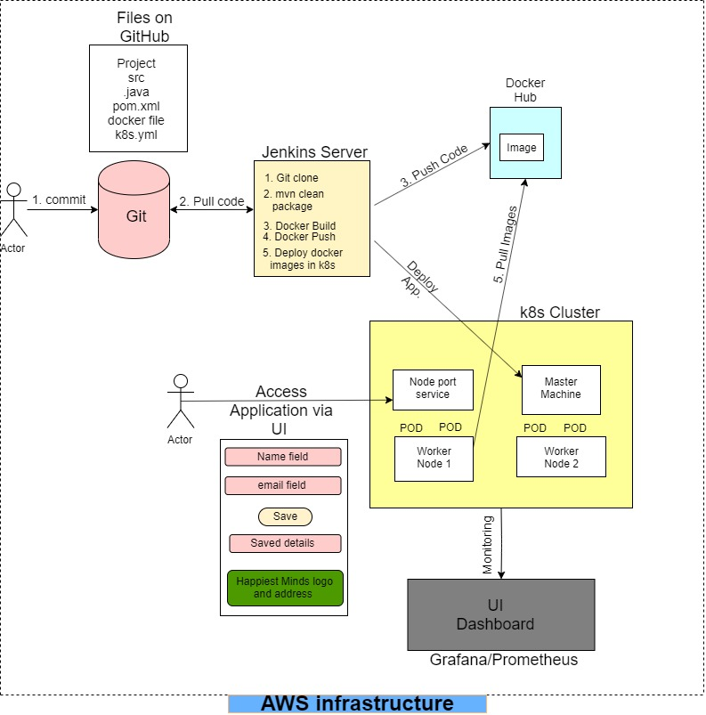

Steps 1: Setup of Jenkins server with docker installed

1. Launch ubuntu instance in AWS
2. Install Java
ubuntu@ip-172-31-30-115:~$ sudo apt update
ubuntu@ip-172-31-30-115:~$ sudo apt install openjdk-8-jdk

3. Add the jenkins debian repository
Import the GPG key of the jenkins repository using following wget command

ubuntu@ip-172-31-30-115:~$ wget -q -O - https://pkg.jenkins.io/debian/jenkins.io.key | sudo apt-key add -
OK
ubuntu@ip-172-31-30-115:~$

4. Add the jenkins repository
ubuntu@ip-172-31-30-115:~$ sudo sh -c 'echo deb https://pkg.jenkins.io/debian-stable binary/ > /etc/apt/sources.list.d/jenkins.list'

5. Install jenkins
ubuntu@ip-172-31-30-115:~$ sudo apt update
ubuntu@ip-172-31-30-115:~$ sudo apt install jenkins
ubuntu@ip-172-31-30-115:~$ systemctl status jenkins

Now access jenkins through http://18.188.202.206:8080/
ubuntu@ip-172-31-30-115:~$ sudo cat /var/lib/jenkins/secrets/initialAdminPassword
39595dabd3a04781a21328d71e2d4839
ubuntu@ip-172-31-30-115:~$

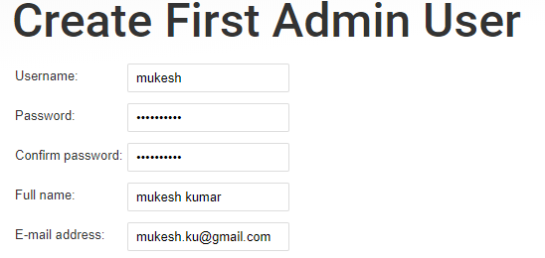
Password: Mukesh@123
http://18.224.137.111:8080/

Update the admin password:
user: admin/Mukesh@123

6. Install Docker
Will be building images in jenkins server so will be installing docker in jenkins server and deployment will happen in kubernetes server.

Install Docker:
ubuntu@ip-172-31-30-115:~$ sudo curl -fsSL get.docker.com | /bin/bash

Add Jenkins user to Docker group:
ubuntu@ip-172-31-30-115:~$ sudo usermod -aG docker jenkins
ubuntu@ip-172-31-30-115:~$ sudo systemctl restart jenkins

Steps 2: Setup Kubernetes Cluster

Create 2 ubuntu inatances for master and worker node
System Requirement:
Master Machine: 4 GB RAM,2 Core processor (t2.medium)
Worker Machine: 1 GB RAM, 1 Core Processor (t2.micro)

Steps for Master and Woker:
ubuntu@ip-172-31-8-157:~$ sudo apt-get update -y
ubuntu@ip-172-31-8-157:~$ sudo apt-get install -y apt-transport-https
ubuntu@ip-172-31-8-157:~$ sudo su -
root@ip-172-31-8-157:~# curl -s https://packages.cloud.google.com/apt/doc/apt-key.gpg | apt-key add -
root@ip-172-31-8-157:~# cat <<EOF >/etc/apt/sources.list.d/kubernetes.list
deb http://apt.kubernetes.io/ kubernetes-xenial main
EOF
root@ip-172-31-8-157:~# apt-get update -y
root@ip-172-31-8-157:~# swapoff -a
root@ip-172-31-8-157:~# sed -i '/swap/s/^\(.*\)$/#\1/g' /etc/fstab
root@ip-172-31-8-157:~# modprobe br_netfilter (To enable ip tables)
root@ip-172-31-8-157:~# sysctl -p
root@ip-172-31-8-157:~# sudo sysctl net.bridge.bridge-nf-call-iptables=1
root@ip-172-31-8-157:~# apt install docker.io -y
root@ip-172-31-8-157:~# usermod -aG docker ubuntu
root@ip-172-31-8-157:~# systemctl restart docker
root@ip-172-31-8-157:~# systemctl enable docker.service
root@ip-172-31-8-157:~# apt-get install -y kubelet kubeadm kubectl kubernetes-cni
root@ip-172-31-8-157:~# systemctl daemon-reload
root@ip-172-31-8-157:~# systemctl start kubelet
root@ip-172-31-8-157:~# systemctl enable kubelet.service

Execute below command in master machine:
root@ip-172-31-8-157:~# kubeadm init
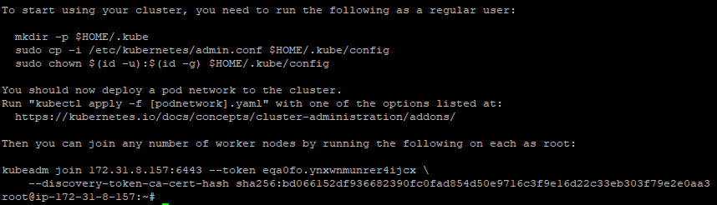
Now exit from root user and execute as normal user (output of above)

mkdir -p $HOME/.kube
sudo cp -i /etc/kubernetes/admin.conf $HOME/.kube/config
sudo chown $(id -u):$(id -g) $HOME/.kube/config

Check status of node:
ubuntu@ip-172-31-8-157:~$ kubectl get nodes
NAME STATUS ROLES AGE VERSION
ip-172-31-8-157 NotReady master 2m56s v1.16.2
ubuntu@ip-172-31-8-157:~$

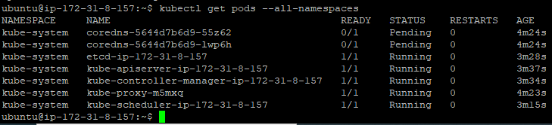
ubuntu@ip-172-31-8-157:~$ kubectl apply -f "https://cloud.weave.works/k8s/net?k8s-version=$(kubectl version|base64|tr -d '\n')"

serviceaccount/weave-net created
clusterrole.rbac.authorization.k8s.io/weave-net created
clusterrolebinding.rbac.authorization.k8s.io/weave-net created
role.rbac.authorization.k8s.io/weave-net created
rolebinding.rbac.authorization.k8s.io/weave-net created
daemonset.apps/weave-net created

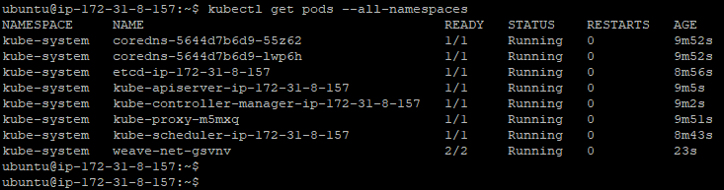

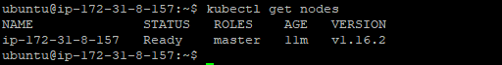

Get token again incase of lost:
ubuntu@ip-172-31-8-157:~$ kubeadm token create --print-join-command
kubeadm join 172.31.8.157:6443 --token hmln8i.kle4gu5tc2c2idk4 --discovery-token-ca-cert-hash sha256:bd066152df936682390fc0fad854d50e9716c3f9e16d22c33eb303f79e2e0aa3
ubuntu@ip-172-31-8-157:~$

copy the token and paste in worker node:
ubuntu@ip-172-31-16-192:~$ sudo kubeadm join 172.31.8.157:6443 --token hmln8i.kle4gu5tc2c2idk4 --discovery-token-ca-cert-hash sha256:bd066152df936682390fc0fad854d50e9716c3f9e16d22c33eb303f79e2e0aa3

Error Kubelet was not running hence not able to join-
cd /etc/systemd/system/kubelet.service.d/
mv 10-kubeadm.conf 10-kubeadm.conf_bkp

error execution phase preflight: [preflight] Some fatal errors occurred:
[ERROR Port-10250]: Port 10250 is in use

root@ip-172-31-39-224:~# netstat -lnp | grep 10250
tcp6 0 0 :::10250 :::* LISTEN 14555/kubelet
root@ip-172-31-39-224:~#
root@ip-172-31-39-224:~# kill 14555

Still unable to resolve recreated the master and worker nodes and waited for few mins before executing kubeadm join command and then worked.

ubuntu@ip-172-31-3-93:~$ sudo kubeadm join 172.31.15.40:6443 --token vtf2iq.6d6e4jkdct8kc5c8 --discovery-token-ca-cert-hash sha256:37973e7064b76af1d37c776ed436c3d42bd4bcb084e342bf0fda2e861cbf272a

Verify in master machine both master and worker in ready state:
ubuntu@ip-172-31-15-40:~$ kubectl get nodes
NAME STATUS ROLES AGE VERSION
ip-172-31-15-40 Ready master 12m v1.16.3
ip-172-31-3-93 Ready <none> 2m33s v1.16.3

Cluster Machine setup is completed.

Steps 3: Jenkins pipeline jobs creation
1. Install Maven:
Manage jenkins -> Global tool configuration -> Maven
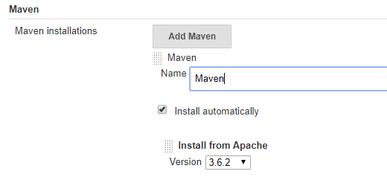
Apply and save.

2. Create pipeline job scripted method:

node{
stage("Git clone"){
git credentialsId: 'GIT_CREDENTIALS', url: 'https://github.com/mbaurnwal546/spring-boot-mongo-docker.git'
}
stage("Maven clean build"){
def mavenHome = tool name: "Maven", type: "maven"
def mavenCMD = "${mavenHome}/bin/mvn "
sh "${mavenCMD} clean package"
}
stage("Build docker image"){
sh "docker build -t mbaurnwal546/spring-boot-mongo:$BUILD_NUMBER ."
}
stage("Docker push"){
withCredentials([string(credentialsId: 'DOCKER_HUB_CREDENTIALS', variable: 'DOCKER_HUB_CREDENTIALS')]) {
sh "docker login -u mbaurnwal546 -p ${DOCKER_HUB_CREDENTIALS}"
}
sh "docker push mbaurnwal546/spring-boot-mongo:$BUILD_NUMBER"
}
}

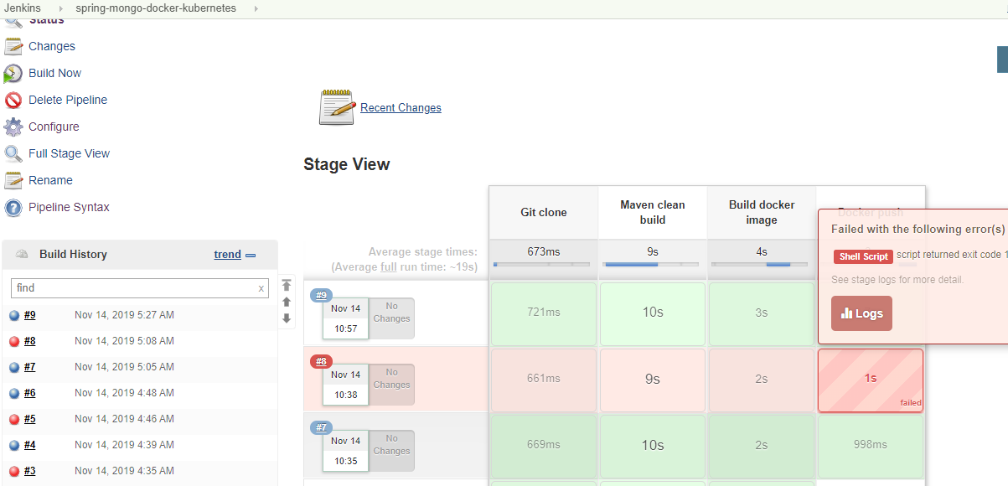

Verify image is build to DockerHub repo

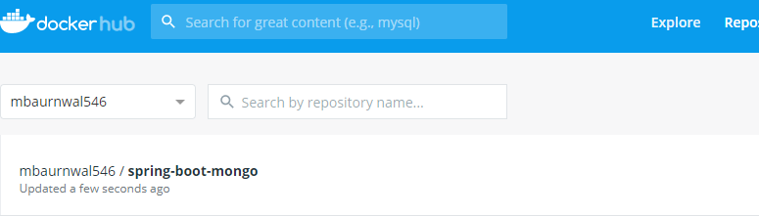

Step4: Setup jenkins server to deploy application into kubernetes

1. Install the kubernetes contineous deploy Plugins:

Manage plugins --> Search for kubernetes contineous deploy plugins and install it.
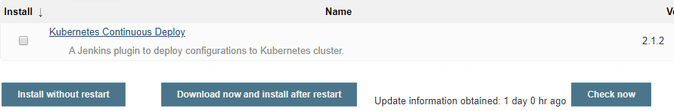
2. Authenticate jenkins server to communicate with kubernetes master server.
Go to credential of jenkins dashboard page -->Add credential
From kubernetes master server get details from kube config file $HOME/.kube/config
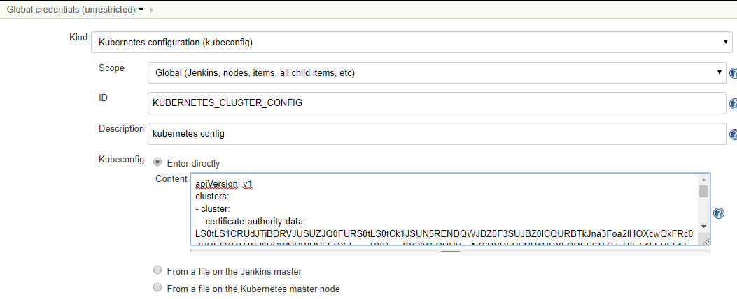
save
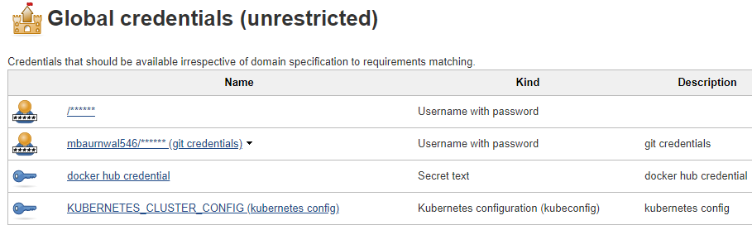
Go to pipeline job and add stage for kubernetes deployments
stage("Deploy Application in k8s cluster") {
kubernetesDeploy(
configs: 'springBootMongo.yml',
kubeconfigId: 'KUBERNETES_CLUSTER_CONFIG',
enableConfigSubstitution: true
)
}

Ttigger the job

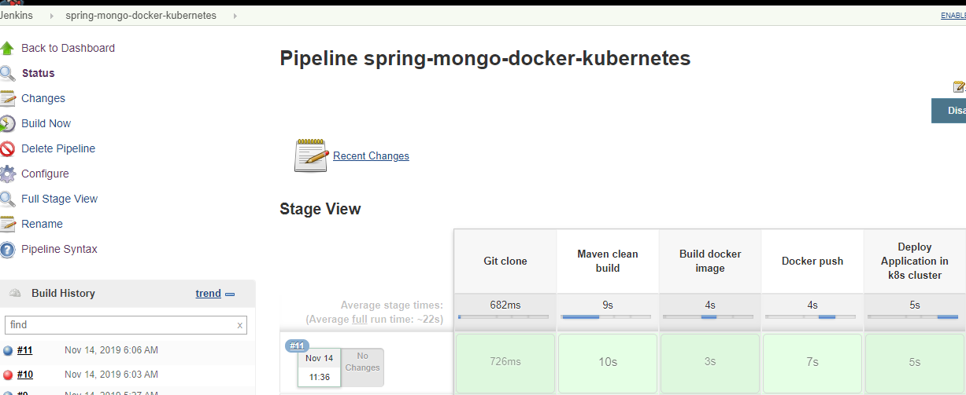

Verify in from kubernetes master server:

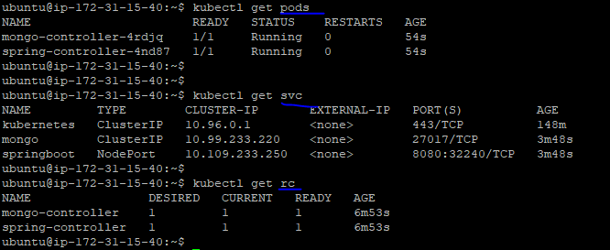
Now application should be accessible:
Take the ip of master node and NodePort from above svc
http://18.221.41.115:32240

Since happiest minds blocked so accessing from mobile

Setup Monitoring with Prometeus and Grafana:

http://localhost:30294/actuator/

http://localhost:30294/actuator/metrics
there's a bunch of information about our application here, such as information about threads, Tomcat sessions, classes, the buffer, etc

http://localhost:30294/actuator/metrics/jvm.memory.used

1. Downloading Prometheus:

ubuntu@ip-172-31-12-89:~$ docker pull prom/prometheus
Using default tag: latest
latest: Pulling from prom/prometheus
Digest: sha256:907e20b3b0f8b0a76a33c088fe9827e8edc180e874bd2173c27089eade63d8b8
Status: Image is up to date for prom/prometheus:latest

ubuntu@ip-172-31-12-89:~$ docker images ls
prom/prometheus latest 7317640d555e 4 weeks ago 130MB

2. Create Prometheus Configuration (prometheus.yml)

vi prometheus.yml
ubuntu@ip-172-31-3-83:~/test$ cat prometheus.yml
global:
scrape_interval: 10s

scrape_configs:
- job_name: 'prometheus'
static_configs:
- targets: ['localhost:9090']
- job_name: 'spring_boot'
metrics_path: '/actuator/prometheus'
scrape_interval: 5s
static_configs:
- targets: ['18.220.213.62:31143']

ubuntu@ip-172-31-3-83:~/test$

3. Running Prometheus using Docker
docker run -d -p 9090:9090 -v /home/ubuntu/test/prometheus.yml:/etc/prometheus/prometheus.yml prom/prometheus

ubuntu@ip-172-31-12-89:~/prometheus-2.14.0.linux-amd64$ docker container ls | grep prom
62e7cd656e25 prom/prometheus "/bin/prometheus --c…" 42 seconds ago Up 41 seconds 0.0.0.0:9090->9090/tcp prometheus
ubuntu@ip-172-31-12-89:~/prometheus-2.14.0.linux-amd64$

4. Visualizing Spring Boot Metrics from Prometheus dashboard
We can now navigate to http://18.220.213.62:9090 to explore the Prometheus dashboard.

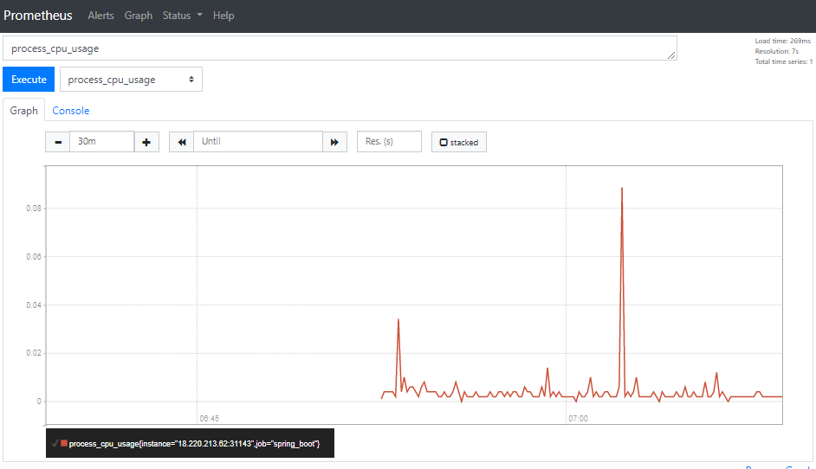

Downloading and running Grafana using Docker:

1. Command to download and run Grafana using Docker -
ubuntu@ip-172-31-12-89:~$ docker run -d --name=grafana -p 9091:3000 grafana/grafana

The above command will start Grafana inside a Docker container and make it available on port 9091 on the Host machine

ubuntu@ip-172-31-12-89:~$ docker container ls | grep grafana
d6eed871b02f grafana/grafana "/run.sh" About a minute ago Up About a minute 0.0.0.0:9091->3000/tcp grafana
ubuntu@ip-172-31-12-89:~$

we can now navigate to http://localhost:9091 and log in to Grafana with the default username admin and password admin



